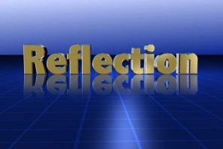Optics Lab
Using Mirrors
Name: ____________________________________________________ Block: ________
Learning Goals:
- To learn how light reflected off of plane mirrors, convex mirrors, and concave mirrors
Behaviour Goals:
- To read through the procedures outlined in the lab and try to problem solve with your lab partner prior to asking the teacher
- To act slowly and safety in the lab for the entire duration of the lab activity.

Vocabulary to Know:
- Plane mirrors: regular, Flat mirrors
- Specular reflection: reflection off a smooth, shiny surface
- Diffuse reflection: when light hits and scatters off an irregular surface
- Convex mirror: when a mirror has the reflecting surface on the inside of the curve
- Concave mirror: when a mirror has the reflecting surface on the outside of the curve
Part #1: Reflecting Off Plane Mirrors
Materials Needed Plane mirror, ray box with single slit, protractor, ruler, pencil, white paper
Procedure
- Read through each part of the following Part #1 procedure. Summarize with your lab partner what you are supposed to do
- Set up your plane mirror (flat mirror) upright along the paper (see below). Shine the ray box at a known angle (angle of incidence = 45 degrees).
- Measure the angle of reflection
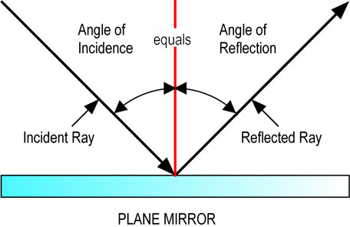

- Draw your set-up and label your angle of incidence and angle of reflection

- What did you notice about the angle of incidence and the angle of reflection? ______________________________________________________________________________________________________________________________________________________________________________________

- What happens if you change the angle of incidence to 70 degrees? ______________________________________________________________________________________________________________________________________________________________________________________
Part #2: Reflecting Off Diffuse Surfaces
Materials Needed Aluminum foil plate, ray box with single slit, protractor, ruler, pencil, white paper
Procedure
- Read through each part of the following Part #2 procedure. Summarize with your lab partner what you are supposed to do
- Set up your diffuse mirror upright along the paper (similar to part 1). Shine the ray box at a known angle (angle of incidence = 45 degrees).
- Make observations about the way the light is being reflection
- Draw below, labelling the incoming light rays and the reflected light rays:

- What did you notice about the way that light was reflected off of a diffuse surface? ______________________________________________________________________________________________________________________________________________________________________________________

- What are 3 examples of diffuse surfaces that reflect light? ______________________________________________________________________________________________________________________________________________________________________________________

Part #3A: Reflecting Off Convex Mirrors
Materials Needed Convex mirror, ray box with triple slit, ruler, pencil, white paper
Procedure Convex Mirrors
- Read through each part of the following Part #3 procedure. Summarize with your lab partner what you are supposed to do
- Set up your convex mirror upright along the paper (see below). Shine the ray box at 90 degrees to the mirror
- Draw the set-up of the convex mirror. Label the incoming light rays and the reflected light rays:

- What did you notice about the way the light reflected off the convex mirror? ______________________________________________________________________________________________________________________________________________________________________________________

- How would this type of reflection be useful? ______________________________________________________________________________________________________________________________________________________________________________________

Part #3B: Reflecting Off Concave Mirrors
Materials Needed Concave mirror, ray box with triple slit, ruler, pencil, white paper
Procedure Concave Mirrors
- Read through each part of the following Part #3B procedure. Summarize with your lab partner what you are supposed to do
- Set up your concave mirror upright along the paper (see below). Shine the ray box at 90 degrees to the mirror
- Draw the set-up of the concave mirror. Label the incoming light rays and the reflected light rays:

- What did you notice about the way the light reflected off the concave mirror? ______________________________________________________________________________________________________________________________________________________________________________________

- How would this type of reflection be useful? ______________________________________________________________________________________________________________________________________________________________________________________

Self Assessment of Goals
- Using your own words, explain how light is reflected off of plane mirrors, convex mirrors, and concave mirrors. ____________________________________________________________________________________________________________________________________________________________________________________________________________________________________________________________

- How did you do on the behaviour goals today?
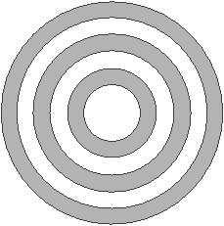
Behaviour Goal:
To read through the procedures outlined in the lab and try to problem solve with your lab partner prior to asking the teacher

Behaviour Goal:
To ask clear questions to help you clarify your understanding

