Math 8 Final Exam
Study Practice

This is some suggested textbook study questions that can help you prepare for your final exam the first week of June. Start with the learning goals that you need the most practice with. I would recommend that once you have completed the learning goal questions:
- use the answers in the back of the book to check if you are correct
- If you did not get a couple correct, go back and redo them and see if you can find your errors
- If you got several incorrect, come in to see Mrs. Arcuri for extra help before school, at lunch, or after school. Note: Wednesday’s after school is Mrs. Arcuri’s Math Club to get extra help

Learning Goals:
- I can find perfect squares and square roots using grids and numbers
  - Pg 9 #10, 11, 12, 15, 16
  - Pg 15 #5, 7, 9, 11, 13
  - Pg 20 #8, 9, 10

- I can estimate the square root of numbers that are not perfect squares
  - Pg 25 #8, 9, 10, 11

- I can demonstrate an understanding of percents greater than 0%
  - Pg 246 #5, 6, 8, 10
  - Pg 252 #3, 4, 7
  - Pg 260 #4, 5, 6, 7

- I can demonstrate an understanding of ratios and rates
  - Pg 266 #4, 5, 6, 7, 8
  - Pg 274 #5, 6, 7, 8, 9, 10
  - Pg 284 #9, 10
  - Pg 291 #8, 9
  - Pg 298 #8, 9, 10, 11
  - Pg 304 #9, 10, 11
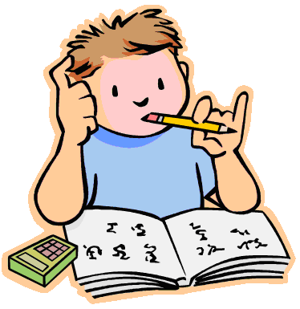
- I can multiply and divide positive fractions and mixed numbers
  - Pg 113 #5, 6, 7, 8
  - Pg 119 #7, 8, 9
  - Pg 125 #4,5, 6, 7
  - Pg 133 #5, 6, 7, 9
  - Pg 139 #4, 5, 6, 7,8
  - Pg 145 #5,6,8,10

- I can multiply and divide positive and negative integers using both tiles and numbers
  - Pg 68 #5, 8, 9, 12
  - Pg 73 #4, 5, 7, 8
  - Pg 81 #8, 9, 10, 11
  - Pg 92 #7, 8, 9, 10

- I can graph and analyse two variable linear relations
  - Pg 356 #4, 8, 9
  - Pg 363 #4, 5, 7

- I can solve for X both pictorially using algebra tiles (or balances) as well as numerically
  - Pg 324 #6, 7, 9, 11
  - Pg 336 #3, 6, 7, 8, 10
  - Pg 342 #8, 9, 12
  - Pg 347 #4, 5, 8
- I can use the Pythagorean Theorem to solve right triangle problems
  - Pg 34 #4, 5, 6, 8, 9
  - Pg 43 #3, 6, 8, 9
  - Pg 49 #5, 6, 7, 8

- I can draw and construct nets for 3D objects
  - Pg 180 #3, 4, 5

- I can determine surface area for right rectangular prisms, right triangular prisms, and right cylinders
  - Pg 186 #4, 5, 6, 8, 9
  - Pg 191 #5,6,7, 9
  - Pg 212 #4, 6, 8

- I can determine volume for right prisms and right cylinders
  - Pg 198, 5, 6, 7, 9
  - Pg 205 #3,4, 5
  - Pg 218 #4, 5, 8

- I can draw the top, front, and side views of 3D objects of right prisms
  - Pg 174 #4, 5, 6, 7, 8, 9

- I can explain the properties of tessellations
  - Pg 477 #7,8, 9

- I can critique ways in which data is graphically and statistically presented
  - Pg 387 #3, 4, 5, 6
  - Pg 399 #3, 4, 5

- I can solve probability of independent events
  - Pg 420 #4, 5, 6, 7, 8

