Adding/Subtracting Fractions
Method 1: Improper Fraction
10/4 + 5/4
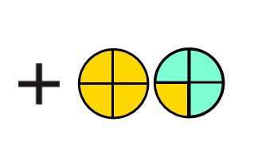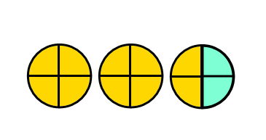

Now you try using the improper fraction method:
- 4 2/10 + 2 3/10 c) 2 3/5 - 1 2/5

- 4 5/6 - 2 1/6 d) 5 1/3 + 1 1/3

Method 2: Use Mixed Numbers
2 2/4 + 1 ¼
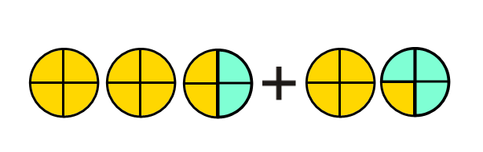

Now you try using the mixed fraction method:
- 4 2/10 + 2 3/10 c) 2 3/5 - 1 2/5

- 4 5/6 - 2 1/6 d) 5 1/3 + 1 1/3

- 1 4/5 + 2 2/3

- 4 1/4 + 3 1/5

- 4 2/3 + 3 1/5

- 3 1/2 - 2 1/3

- 5 3/4 - 2 1/3

- 2 1/3 – 5 3/8

- 1 2/3 + 3 1/9

- 4 3/4 - 2 3/8

- 5 1/3 - 3 ¼

- 6 2/5 + 3 1/2

